October 25, 2012

Hello again from all of us at the Mission Office! I am writing to remind you of the special collection which will be held for our sister parish in the Dominican Republic on December 8-9th.
This special collection for La Sagrada Familia will provide needed support for their parish ministries that include a nutrition center for children, a support ministry for those in prison and a literacy program for those learning to read and write. It will also help cover the salaries of the priests and the parish employees.
In 1981, a young diocese with people living in one of the poorest sections of the Dominican Republic was praying for someone to accompany them on their faith journey. In choosing to begin this relationship, the Archdiocese of Milwaukee committed itself to becoming a partner with the people of La Sagrada Familia Parish.
Over the past 30 years, the bonds of friendship have continued to grow between the parishioners of our Archdiocese and the parishioners of La Sagrada Familia. We have continued to walk together as partners and friends, who learn from one another and accompany one another in our journey of faith and in our commitment to help build greater global solidarity.
To support this spirit of partnership which guides this collection, we will be providing the following resources:
  - Brief pulpit announcements for Sunday Masses prior to and including December 8-9
  - Envelope and card for parish check (enclosed). Please ask parishioners to address checks to your parish and send one check addressed to Office for World Mission
  - Bi-lingual prayer cards from La Sagrada Familia for interested parishioners to be displayed in pews or the back of church during the weekend of December 8-9. We will mail or deliver cards in early November.
  - Specific information prepared for Bulletin editors to assist them in raising awareness of this effort, including stories and images
  - A webpage containing these resources. Please visit:
http://www.archmil.org/parishes/Sagrada-Familia/SagradaFamiliaSpecialCollection2012.htm
We count on your leadership and support in raising awareness of our archdiocesan relationship with La Sagrada Familia and encouraging parish participation in this collection as a way of strengthening the bonds of faith and friendship. Please let us know if we can be of further assistance to you.
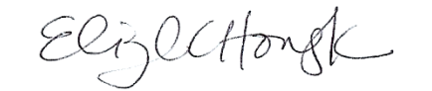
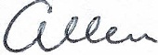
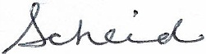
Sincerely,

Allen Scheid Elizabeth Howayeck
Director International Mission Coordinator

