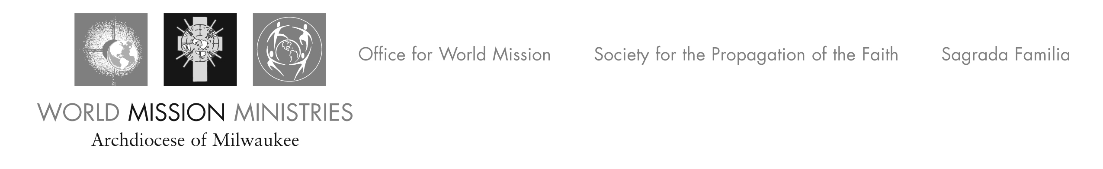
August 3, 2012

Greetings from the Mission Office. I am writing to remind you that the special collection for La Sagrada Familia will be held in the parishes on December 8-9th. The Archdiocesan Priest Council chose this weekend because of its proximity to the feast of Our Lady of Guadalupe, the Patroness of the Americas.
For more than 30 years now, the Archdiocese has been sending diocesan priests to serve in the parish which is located in the western part of the Dominican Republic. For many years, the Office for World Mission has raised funds to cover the annual salaries of two priests and the yearly parish budget for La Sagrada Familia. (This year we will be sending the parish about $300,000 to pay for these expenses.)
We have been collecting these funds from an annual fundraiser, a spring mailing, and a number of parish collections in the Mission Cooperative Program during the summer. Because this is an Archdiocesan partnership, the Priest Council agreed last year to a request for a special (second) collection from all the parishes for 3 years. (This is the second year of the extra collection for La Sagrada Familia Parish.)
By means of this letter, we are inviting all the parishes of the Archdiocese to participate once again in this special collection for our sister parish. We recognize that these are hard times for many families. We hope this collection won’t be too much of a burden for you and your parishioners. Last year, 134 parishes participated in the collection and donated a total of $163,804 for La Sagrada Familia Parish. We want to say thanks again to all of you for your kind generosity!
In the coming months, we will explore ways to help La Sagrada Familia become a more self-sufficient parish. Our call to Global Solidarity is a call to continue developing partnerships that are about sharing our faith journeys, developing friendships across cultures, and promoting social justice and peace.
Thank you for considering this invitation to participate in the special collection on December 8-9th.
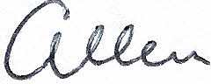
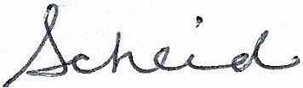
Sincerely,

Allen Scheid
Director

P.S. Sister Frances Cunningham, OSF has retired, after serving 17 years as the Director of the Mission Office. We will strive to do our best to build on her great work and dedication.
If you have questions, suggestions, or complaints along the way, please let me know. We are accountable to you and all the people of our Archdiocese.
Allen

