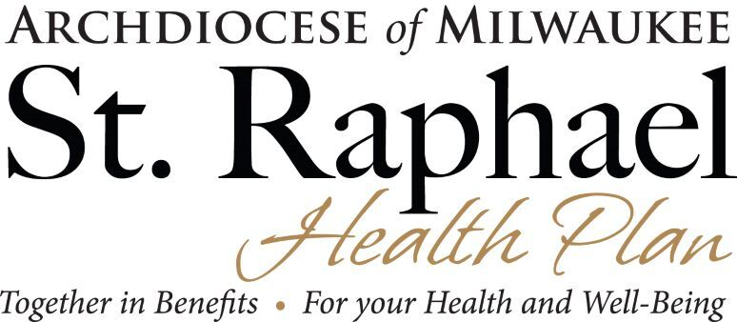

We are on schedule with our transition to the MyEnroll360 benefits administration platform. Benefit Allocation Systems (BAS) is building our platform and our insurance carriers are now actively engaged in the process.

As previously communicated, this change aligns with the strategic plan of the Archdiocese to provide shared services to our parishes and schools. We know how challenging your jobs can be, so transitioning to a platform that has the potential to simplify and automate the administration of so many functions is a positive move.

To keep you abreast of our progress during the transition, we will send updates periodically and share information that will be important for you to know. These communications may include an action item for you to complete, as does today’s communication, and we respectfully request that you respond promptly.

Phase 1 of this transition includes online enrollment and other benefits administration, premium billing, collection, and remittance, Continuation of Coverage services, and ACA administration and reporting services. With MyEnroll360, you can expect the following:
- Employee data is housed in one spot.
- New hire, life events, and plan year benefits enrollment is online.
- Electronic file feeds to the carriers ensure accuracy and timeliness.
- Simplified billing--one bill for medical, dental, vision, and Life/AD&D insurance, with ACH direct debit payments to BAS.
- Simplified ACA compliance and administration--recordkeeping, reporting, and e-filing at no additional cost to you.
- Continuation of Coverage administration.
- Access to benefits documents and educational resources via a Resource Library, webinars, tutorials, and a weekly e-newsletter communication.
- Improved communications capabilities.

Phase 2 of this initiative, which is not yet scheduled and may be subject to change, includes adding pension and other/additional benefits administration to the platform, total compensation statements, payroll integration opportunities, and a focus on communications.

ACTION ITEM
As for now, continue to administer your benefits as you currently do and, as always, thank you for your great work.
Together in Benefits for your Health and Wellbeing,

Maureen Wurster
HR and Benefits Administrator
414-769-3423
wursterm@archmil.org

